**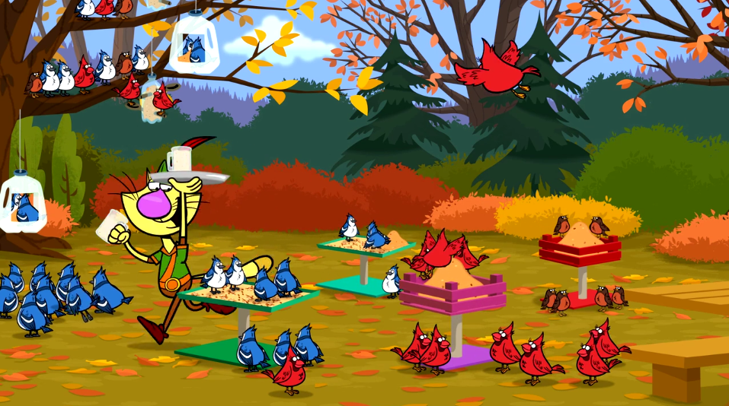**

**Fine Feathered Feast**

**Game Design Document 06/02/17**

Table of Contents

[High Level Concept 4](#_Toc484182929)

[Overview 4](#_Toc484182930)

[The Set Up 4](#_Toc484182931)

[The Challenge 4](#_Toc484182932)

[The Goal 4](#_Toc484182933)

[Game Screen 5](#_Toc484182934)

[Gameplay 6](#_Toc484182935)

[Level One: Tutorial 7](#_Toc484182936)

[Level 2 11](#_Toc484182937)

[Level 3 12](#_Toc484182938)

[Level 4 13](#_Toc484182939)

[Level 5 14](#_Toc484182940)

[Level 6 15](#_Toc484182941)

[Level 7 16](#_Toc484182942)

[Level 8 17](#_Toc484182943)

[Level 9 18](#_Toc484182944)

[Level 10 19](#_Toc484182945)

[Main Learning Goals 20](#_Toc484182946)

[Top Level Topic: Science 20](#_Toc484182947)

[Science Sub- Topic- Life Science 20](#_Toc484182948)

[Crosscutting learning concepts 21](#_Toc484182949)

[Game Mechanics 23](#_Toc484182950)

[Basic Game Mechanic 23](#_Toc484182951)

[Basic Steps / Interactions for the User 23](#_Toc484182952)

[Rules that govern gameplay and interact with the mechanics 24](#_Toc484182953)

[Interaction Feedback 25](#_Toc484182954)

[Wining/losing 26](#_Toc484182955)

[Leveling 27](#_Toc484182956)

[Basic Game Flow 28](#_Toc484182957)

[Technical Specs 31](#_Toc484182958)

[Framework & High Level Specs 31](#_Toc484182959)

[Browser / OS support 31](#_Toc484182960)

[Aspect Ratio & Dimensions 32](#_Toc484182961)

[Multi-resolution Assets 33](#_Toc484182962)

[Orientation 33](#_Toc484182963)

[Technical Approach 34](#_Toc484182964)

# High Level Concept

## Overview

Based loosely around the humor and learning concepts of *Nature Cat*’s “For the Birdies” episode, “Fine Feathered Feast” is a game where players help Nature Cat as he tries to help feed his many bird friends.

## The Set Up

With winter coming on, Nature Cat wants to help his fine feathered friends gather food before the snow flies. But it’s harder than he thinks. Different types of birds like different types of food and some birds like to eat up in the trees while others like their food near the ground. If Nature Cat is going to be a successful bird caterer, he’s going to need to plan things out.

## The Challenge

Nature Cat’s backyard is filled with lots of birds. Some like berries, some like seeds and others like acorns. Some like their bird feeders up high and some like them down near the ground. But the one thing they all have in common is that they like their bird feeders well stocked. Can Nature Cat keep the feeders full and his feathered friends fully fed?

## The Goal

Nature Cat’s goal is to satisfy as many feathered friends as possible. And that means keeping them well fed and never letting supplies run out. The game can start out very easy when all you have to do is keep a few customers happy. But when you starting adding more birds, arriving with more frequency, the challenge can get very difficult very quickly.

## Game Screen

The following is a rough concept drawing of what the main screen would look like

## Gameplay

The following is an early script of what gameplay is like. The game mechanic is roughly based on resource management games like “Diner Dash”. The challenge and speed of the gameplay can be dialed up or down based on the abilities of the audience. A more in-depth look at the game mechanics and the levelling are discussed in a later chapter, but the basic are included here to help give a sense of the overall gameplay and progression.

INTRO (*NOTE: knowing that kids generally click through animations in games, the following scene may be shortened or eliminated altogether, in which case the game set up and instructions will be provided within the gameplay field- specifics to be determined in GDD*).

The scene is Nature Cat’s backyard. The trees are showing the last of their fall leaves and the first snowflakes of the season begin to fall. Nature Cat tells his friends that he’d like to help the birds by feeding them some food. How hard could that be? On her PDA, Daisy shows Nature Cat, that it’s probably more complicated than he thinks. Different birds like different types of food types in different feeders. So she suggests that if Nature Cat wants to run a bird diner, he might want to learn the rules.

### Level One: Tutorial

1. The player is presented with bucket of bird feed (seeds) and one bird feeder hung in a tree. The goal of Level One is to successfully feed three birds within a period of time (exact number of birds and length of time TBD).



1. In order to do that, the player is instructed (through voiceover) to move Nature Cat to bucket of seed, scoop up, seed and then climb rope ladder to fill bird feeder.



1. A bird feeder that has one “hole” accommodates just one bird at a time and needs just one scoop to fill. 
2. Once a bird has eaten all the feed in the bird feeder, it flies away a “happy diner” and is logged on the “scoreboard”.



1. The player needs to help Nature Cat successfully do this three times to successfully complete a Level within the given time.
2. If the player does not successfully complete the level, all the birds fly away and the Level begins again.

### Level 2

1. Having successfully completed Level 1, the player is now presented with a second feeder and the task of feeding a larger number of birds within the same time frame.
2. Both feeders require the same type of feed, but the player needs to spend more time juggling activity (parallel work) between two feeders and scooping feed.
3. If a player successfully meets her/his goal of feeding all birds within given time, then the player moves to Level 3.
4. If the player does not successfully complete the level, all the birds fly away and the Level begins again.

### Level 3

1. Having successfully completed Level 2, the player is now presented with a third feeder and the task of feeding a larger number of birds within the same time frame.
2. All three feeders require the same type of feed, but the new feeder can feed 2 birds at once and requires two scoops to fill.
3. No birds will arrive at a feeder unless it’s full, so to feed 2 birds at once on a larger feeder will require two trips to the feed bin.
4. Feeding more birds at once at a larger feeder is more time and labor efficient than feeding them one at a time.

### Level 4

1. Having successfully completed Level 3, the player is now presented the same scene, but this time the goal is to feed more birds in less time.
2. The goal of this level is to reinforce the resource and time management principals presented in the previous level (i.e. feeding more birds at once at a larger feeder is more time and labor efficient than feeding them one at a time).



### Level 5

1. Having successfully completed Level 4, the player is now presented with a new feeder and a new type of bird feed.
2. The feed bins and the feeders are color coded so that players visually understand which type of feed goes in which type of bird feeder (a VO will also explain their differences).
3. The player is also presented with a recycling bin at this level, as it will be possible that a player may need to empty a feed scoop and refill with the appropriate feed (i.e. when a player mistakenly takes a scoop of “yellow seed” when all of the “yellow feeders” are full and what he/she really needs is a scoop of “red seed”).
4. The new challenge in level 5 is not only to keep the feeders full, but to keep them full with the correct feed.



### Level 6

1. Now a player is presented with the challenge of keeping a pesky squirrel out of the feeders.
2. The squirrel won’t approach a feeder filled with birds, but it will approach a feeder that has seed in it (i.e. a partially filled feeder or a filled feeder where a bird has not landed yet).
3. For that reason, the player needs to help Nature Cat stay on his toes and shoo away the squirrel before it gets to a feeder.
4. They do that by tapping on the squirrel when it appears, at which juncture Nature Cat does one of his aerobatic feats of daring, jumps up high, does a flip and knocks the squirrel out of the picture.



### Level 7

1. Having successfully warded of the squirrel, the player is presented with one last bird feeder and a new type of feed bin from which it needs to be filled.
2. This bird feeder accommodates 4 birds, and is the most efficient way to feed multiple birds, but it also open you up to more chances of a squirrel raid.



### Level 8

1. This level provides the additional challenge of adding a second squirrel to the raiding party, making it even harder to keep the feeders filled.
2. If a player successfully meets her/his goal of feeding all birds within given time, then the player moves to Level 9.
3. If the player does not successfully complete the level, all the birds fly away and the Level begins again.



### Level 9

1. This level provides the additional challenge of adding a third squirrel to the raiding party, and the goal of feeding more birds - making it even harder to keep the feeders filled.
2. If a player successfully meets her/his goal of feeding all birds within given time, then the player moves to Level 10.
3. If the player does not successfully complete the level, all the birds fly away and the Level begins again.



### Level 10

1. This level has the same challenges as Level 9, but with even less time on the clock to complete the challenge. 

# Main Learning Goals

The following is based on the guidelines of the PBS KIDS Science Learning Framework:

Top Level Topic: Science

*The study of the natural world, both living and nonliving, through a process of inquiry that includes observation, prediction, and experimentation leading to understanding/explanation.*

Science Sub- Topic- Life Science

*The study of the structure, behaviors and relationships of living organisms*

In specific, as it applies to the Bird Feeder Game:

* Ecosystems and Interactions:
  + Properties and characteristics of living things: *birds need to eat*
  + Basic needs of living things: *birds will eat a variety of things, including seed, dried fruits and nuts, and suet*
  + Behavior of living things: *if birds are presented with food in a safe environment (like a bird feeder), they will eat it. If squirrels are given a chance, they will raid bird feeders.*
  + Relationship between living things and their environment: *when the seasons change, the availability of food for bird changes. It is harder for birds to find food in the winter.*
* Structure & Processes
  + Understand that all animals need food in order to live and grow
  + Understand that all animals get their food from plants or other animals
* Ecosystems, Interactions, Energy and Dynamics
  + Understand that animals depend on other living things and non-living things in the environment to meet some of their needs: birds can compete with other animals (in this case, squirrels) for food.

## Crosscutting learning concepts

* **Cause and effect:** by identifying and observing events, relationships and patterns in the natural and human designed world, children can learn that events have causes that generate observable patterns. *For example, in this game, children will be challenged to understand the events and patterns that allow birds to feed successfully (or not).*
* **Systems and System Models**: By describing systems in terms of parts, roles of parts and relationship among parts, children can understand that systems have parts that work together and that if a part of the system breaks, is removed or altered, the working of the system can change. *For example, in this game, children will be challenged to understand the system and process for keeping bird feeders full, birds fed, and squirrels away from the feeders.*
* **Structure and Function:** By investigating how things work and reflecting on characteristic parts and what they do in both nature and the human designed world, children can observe that the shape, material and parts of a system are related to the function of the object or system. *For example, in this game children will be challenged understand the function and operation of different types of bird feeders and how to maintain them.* **Energy and Matter:** animals need to eat food to get energy: *For example, in this game, children will learn how critical it will be for birds to have food to eat in order to survive through seasonal changes.*
* **Scale, Proportion and Quantity**: By using relative scales to describe objects and standard units, children can compare and describe objects and events in the natural and human-made world. *For example, children will be challenged to recognize the different types of bird feeders; the size of those bird feeders; the number of birds each feeder can accommodate; the number of birds that need to be fed; and the varying time allotted to feed them.*

# Game Mechanics

## Basic Game **Mechanic**

This is a time-based game that takes place in real time.

The user must help Nature Cat feed X number of Birds in T amount of time (w/X and T specified by level).

## Basic Steps / Interactions for the User

The user helps Nature Cat fill the feeders by directing him to fill feeders with feed in 2 steps

1. The user tap/clicks a type of feed near the bottom of the screen
   1. NC fills scoop with 1 scoop of feed
2. The user tap/clicks a bird feeder
   1. NC goes to the bird feeder and deposits 1 scoop of feed.

Higher levels allow the user to either recycle feed or scare award squirrels. In those cases:

1. The user tap/clicks the recycling bin
   1. NC goes to the recycling bin and dumps feed
2. The user tap/clicks the squirrel
   1. NC jumps from wherever he is to the squirrel to scare him away

## Rules that govern gameplay and interact with the mechanics

1 scoop fills 1 available space in a bird feeder

* + A 1 space feeder = 1 scoop = 1 bird at a time
  + A 2 space feeder = 2 scoops = 2 bird at a time
  + A 3 space feeder = 3 scoops = 3 bird at a time
  + A 4 space feeder = 4 scoops = 4 bird at a time

When a feeder is full, and only when it is full, is it considered reading for feeding birds.

This means that it will take NC 1 complete trip (2 taps: feed>feeder) to fill a 1 space feed and 2 trips (4 taps) to fill a 2 space feeder and so on up to 4.

This is the main trade off - it takes longer to fill the higher capacity feeders, but those feeders feed more birds.

Example

FT = 2 sec (2 taps: get feed, fill feeder)

BT = 4 secs (time it takes for bird(s) to feed at feeder)

Time to feed 2 birds with a 1 space bird feeder

1st trip 2 sec

Bird Time to eat 4 sec

2nd trip 2 sec

Bird time to eat 4 sec

TOTAL **12 sec**

Time to feed 2 birds with a 2 space bird feeder

1st trip 2 sec

2nd trip 2 sec

Bird time to eat 4 sec

TOTAL **8 sec**

## Interaction Feedback

It is important to give the user feedback (both audio/visual) that their interactions are either correct or incorrect.

If NC has an empty scoop and the user:

* + Correct: Tap/clicks a feed bag, NC will show his scoop as full, and an audio cue will emphasize
  + Incorrect: Tap/clicks a bird feeder or recycling, the feeder (or area around the bird feeder) will flash red, and a negative audio due will be given

If NC has a full scoop:

* + Correct: Tap/clicks a bird feeder, NC will fill the feeder and bird feeder will fill and a positive audio cue will be given to emphasize
  + Neither Incorrect or Correct: Tap/click recycling, NC will dump feed in recycling and an audio cue will be given
  + Incorrect: Tap/clicks a feed bag, the feed bag (or area around the bag) will flash red, and a negative audio cue will be given

## Wining/losing

The user will ‘win’ a level if all of the birds have been fed before the timer runs out

The user will ‘lose’ a level if all of the birds have not been fed before the timer runs out.

# Leveling

As a general rule, higher levels mean more birds to feed, more types of feed introduced, less time available (per bird) and number of squirrels introduced



# C:\Users\joel\AppData\Local\Microsoft\Windows\INetCache\Content.Word\nature_ca.pngBasic Game Flow

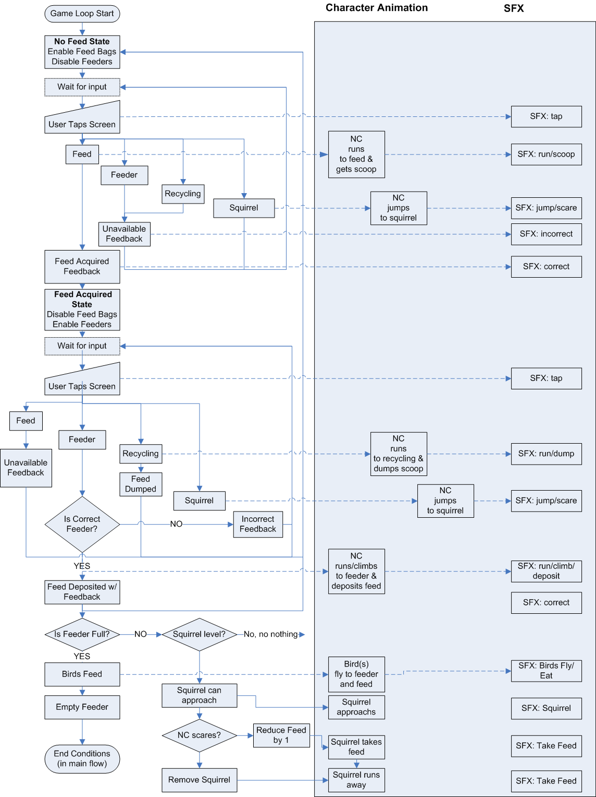

# Technical Specs

## Framework & High Level Specs

The game will be developed as an HTML5 game in the Springroll framework.

**Aspect ratio and Dimensions:** 16x9 (990x560)

**Max Game Size:** 50 MB

**Audio Format:** OGG & MP3

**JS libraries:** Pixi.js will be used as a rendering engine

## Browser / OS support

The following specifications were taken from the PBD producer hub page, “Websites Technical Requirement and Supported Devices” on 6/2/2019 (page last updated 5/26/2017)

**Desktop Support**

**Windows**

* + Win 7+
    - IE 10+, Latest stable version of Chrome and Firefox.
  + Win 8.1
    - IE 11, Edge13+, Latest stable version of Chrome and Firefox
  + Win 10
    - IE 11, Latest stable version of Chrome and Firefox.

**Mac**

* + Mac OS 10.10+
    - Safari 8+, Latest stable version of Chrome and Firefox

**Mobile / Tablet Support**

**iOS**

* Operating System: 9.0+
* Devices: iPad 2+, iPad mini (1st Gen) iPhone 5c+, No iPods
* Browsers: Mobile Safari (latest)

**Android**

* Operating System: Android OS 4.4.2+
* Devices:  Amazon Fire KFFOWI (2015), Samsung SM-T113 Galaxy Tab 3, LG K7 (represents baseline for lower powered phones)
* Browsers: Chrome (Sudden assumes latest version)

## Aspect Ratio & Dimensions

The aspect ratio will be 16x9 at a resolution of 990x560.

This 990 number was determined by examining other PBS games. It should be noted that the previous Nature Cat games were created at a different aspect ratio and overall dimensions.

## Multi-resolution Assets

In previous projects, Sudden has delivered multi-resolution experiences so that a game renders ‘as-good-as-can-be’ and various resolutions and devices. From PBSs producer’s hub:

* Device resolution is a pain, particularly if you care about how your game looks. A typical strategy for multi-platform web games is to include variously sized versions of each asset (e.g., “small”, “medium”, “large”, “large2X”, and “optimal”), then render based on either build configuration or device detection--we don’t advise this.
* Go with one set (if possible) of “optimal resolution” assets, then let the game scale accordingly. The most obvious reason is game size, since we don’t support multiple production builds.

This means that Sudden will create the game assets for the 990x560 above and all other sizes and dimensions will be scaled proportionally, creating the possibility of reduced quality on smaller devices where the heavily outlined art direction of the NC style may suffer.

## Orientation

The orientation will be fixed as landscape following the 16x9 aspect ratio above. This means that the game will scale proportionally on devices in portrait so that the 16x9 is retained. It will not reorient or layout the game differently for portrait (9x16 or otherwise), it will simply be smaller.

# Technical Approach

We believe that what’s going to make or break this game is a solid game mechanic that:

* + Is easy to understand and interact with
  + Is challenging in scope and time allocated
  + Requires attention to decisions, allowing the user to improve with repeat place
  + Is super fun to play

With that in mind, with think getting a basic core mechanic in place in test the underlying ‘playability’ is an important first step.

1. Create repos / build system / basic Springroll wrapper
   1. Set up/access repos
   2. Set up the necessary ‘under-the-hood’ build related scaffolding re: Springroll, Pixi, etc
   3. Use approved Springroll template to set up basic game structure
   4. Set up/review basic states
2. Create main game scene and build core mechanic with/from WFs
   1. This is the first real step of getting a ‘playable’ version
   2. No final graphics used, no animation
   3. Shapes or WFs used as placeholders
   4. Initial scene to include the flow for 1st level (minus the tutorial aspects)
      1. 3 Birds
      2. 1 timer
      3. 1 feeder
      4. 1 type of feed
      5. NC
      6. Text-based tally of birds fed
      7. Basically anything this is required to play 1 level in the most rudimentary form
   5. Config files to hold basic variables
      1. Level time
      2. Level-based # of birds
      3. Level-based # of feeders (though only 1 used for initial set up)
      4. Level-based types of feed (though only 1 used for initial set up)
      5. Level-based # of squirrels (though 0 used in initial set up)
      6. Bird eating time
      7. Time to get feed / fill feeder
3. If the basic game-mechanics feel right and we are to continue development, we’ll then:
   1. Continue to build all levels with
      1. Scoring
      2. Win/lose states
      3. Correct / Incorrect feedback
      4. Tweaks to game variables as needed
   2. Intro / Start Screens
   3. Add graphics as available
      1. Considering asset management / graphic size
   4. Add VOs / SFX
      1. Considering asset management / graphic size
   5. Add animations / tweens as available
      1. Considering asset management / graphic size